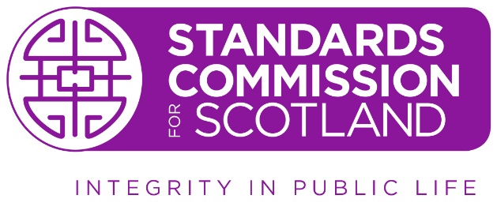

Please provide the information requested in this document so that we can manage the Hearing effectively. Please note that you do not need to answer questions 4 to 7 inclusive, if you do not wish to add to representations already provided on the Ethical Standards Commissioner’s report.

- Please advise if you intend to attend the Hearing (yes or no):

Representation
- Please advise if you will be representing yourself at the Hearing (yes or no):

- If you are being represented, please provide the name and contact details of your representative (including their email address):

Matters in dispute
- Please advise whether you accept all the facts as found by the ESC and outlined in the report (yes or no)

- If you dispute some or all of the facts, please indicate below the key matters that are in dispute:

- If you accept some or all of the facts, please indicate whether or not you accept the ESC’s conclusions outlined in the report:

- If you dispute some or all of the ESC’s conclusions, please indicate below the key matters that are in dispute:

Witnesses
Please note both parties, the Respondent and the ESC, are entitled to call witnesses. However, please note the final decision on whether to accept any witness is a matter for the Hearing Panel. In making such a decision, the Hearing Panel will consider whether the proposed witness will be in a position to give evidence that is directly relevant to the issues of complaint to be considered at Hearing, and also the public interest in ensuring hearings are conducted fairly and efficiently. Please note the ESC will be entitled to cross-examine any witness called on your behalf, and you will be entitled to cross-examine their witnesses. We will advise you if the ESC intends to call any witnesses.

- Please indicate whether you intend to give evidence yourself at the Hearing (yes or no)

Please note, the purpose of calling an individual to give evidence at Hearings is for the Panel to hear what the person witnessed (i.e. what they saw or heard) in respect of any event or incident that is the subject of the complaint. They are not allowed to not give their opinions or present any arguments as to whether the Respondent’s alleged conduct amounts to a breach of the Code. Any such opinions or arguments are submissions. As the Respondent, you are entitled to both give evidence and to make submissions.

- If you propose to call witnesses, please provide:
- their names (and if applicable their job titles)
- a brief summary of the evidence you consider each witness will be able to provide, including why you consider this to be relevant to the issues of complaint to be considered at the Hearing.
- confirmation that each witness has been contacted and is able and willing to attend the Hearing.

- Please advise if you would like the Standards Commission to require an individual to give evidence and / or produce any documents, please provide their name, contact details and the reasons for the request:

Productions
Please note both parties, the Respondent and the ESC, are entitled to submit documents to be considered by the Hearing Panel both in advance and at the Hearing. However, please note the final decision on whether to accept any witness is a matter for the Hearing Panel. In making such a decision, the Hearing Panel will consider whether the proposed document is directly relevant to the issues of complaint to be considered at Hearing, and also the public interest in ensuring hearings are conducted fairly and efficiently.

Please note you are entitled to submit relevant documentation to be added to the productions bundle provided it is received by the Standards Commission no later than 14 days prior to the Hearing.

Written submissions in mitigation
You are also entitled to submit written submissions in mitigation (including any character references) which, in the event of a breach of the Code being found, will be used by the Hearing Panel in determining the sanction to be imposed. These must be received no later than the day before the Hearing.

Reasonable adjustments
- Please let us know if you have any specific need, and we will try to make reasonable adjustments wherever possible.

Questions

If you have any questions about this form or the hearing process, please do not hesitate to contact us via email at enquiries@standardscommission.org.uk or on 0131 348 6666.

